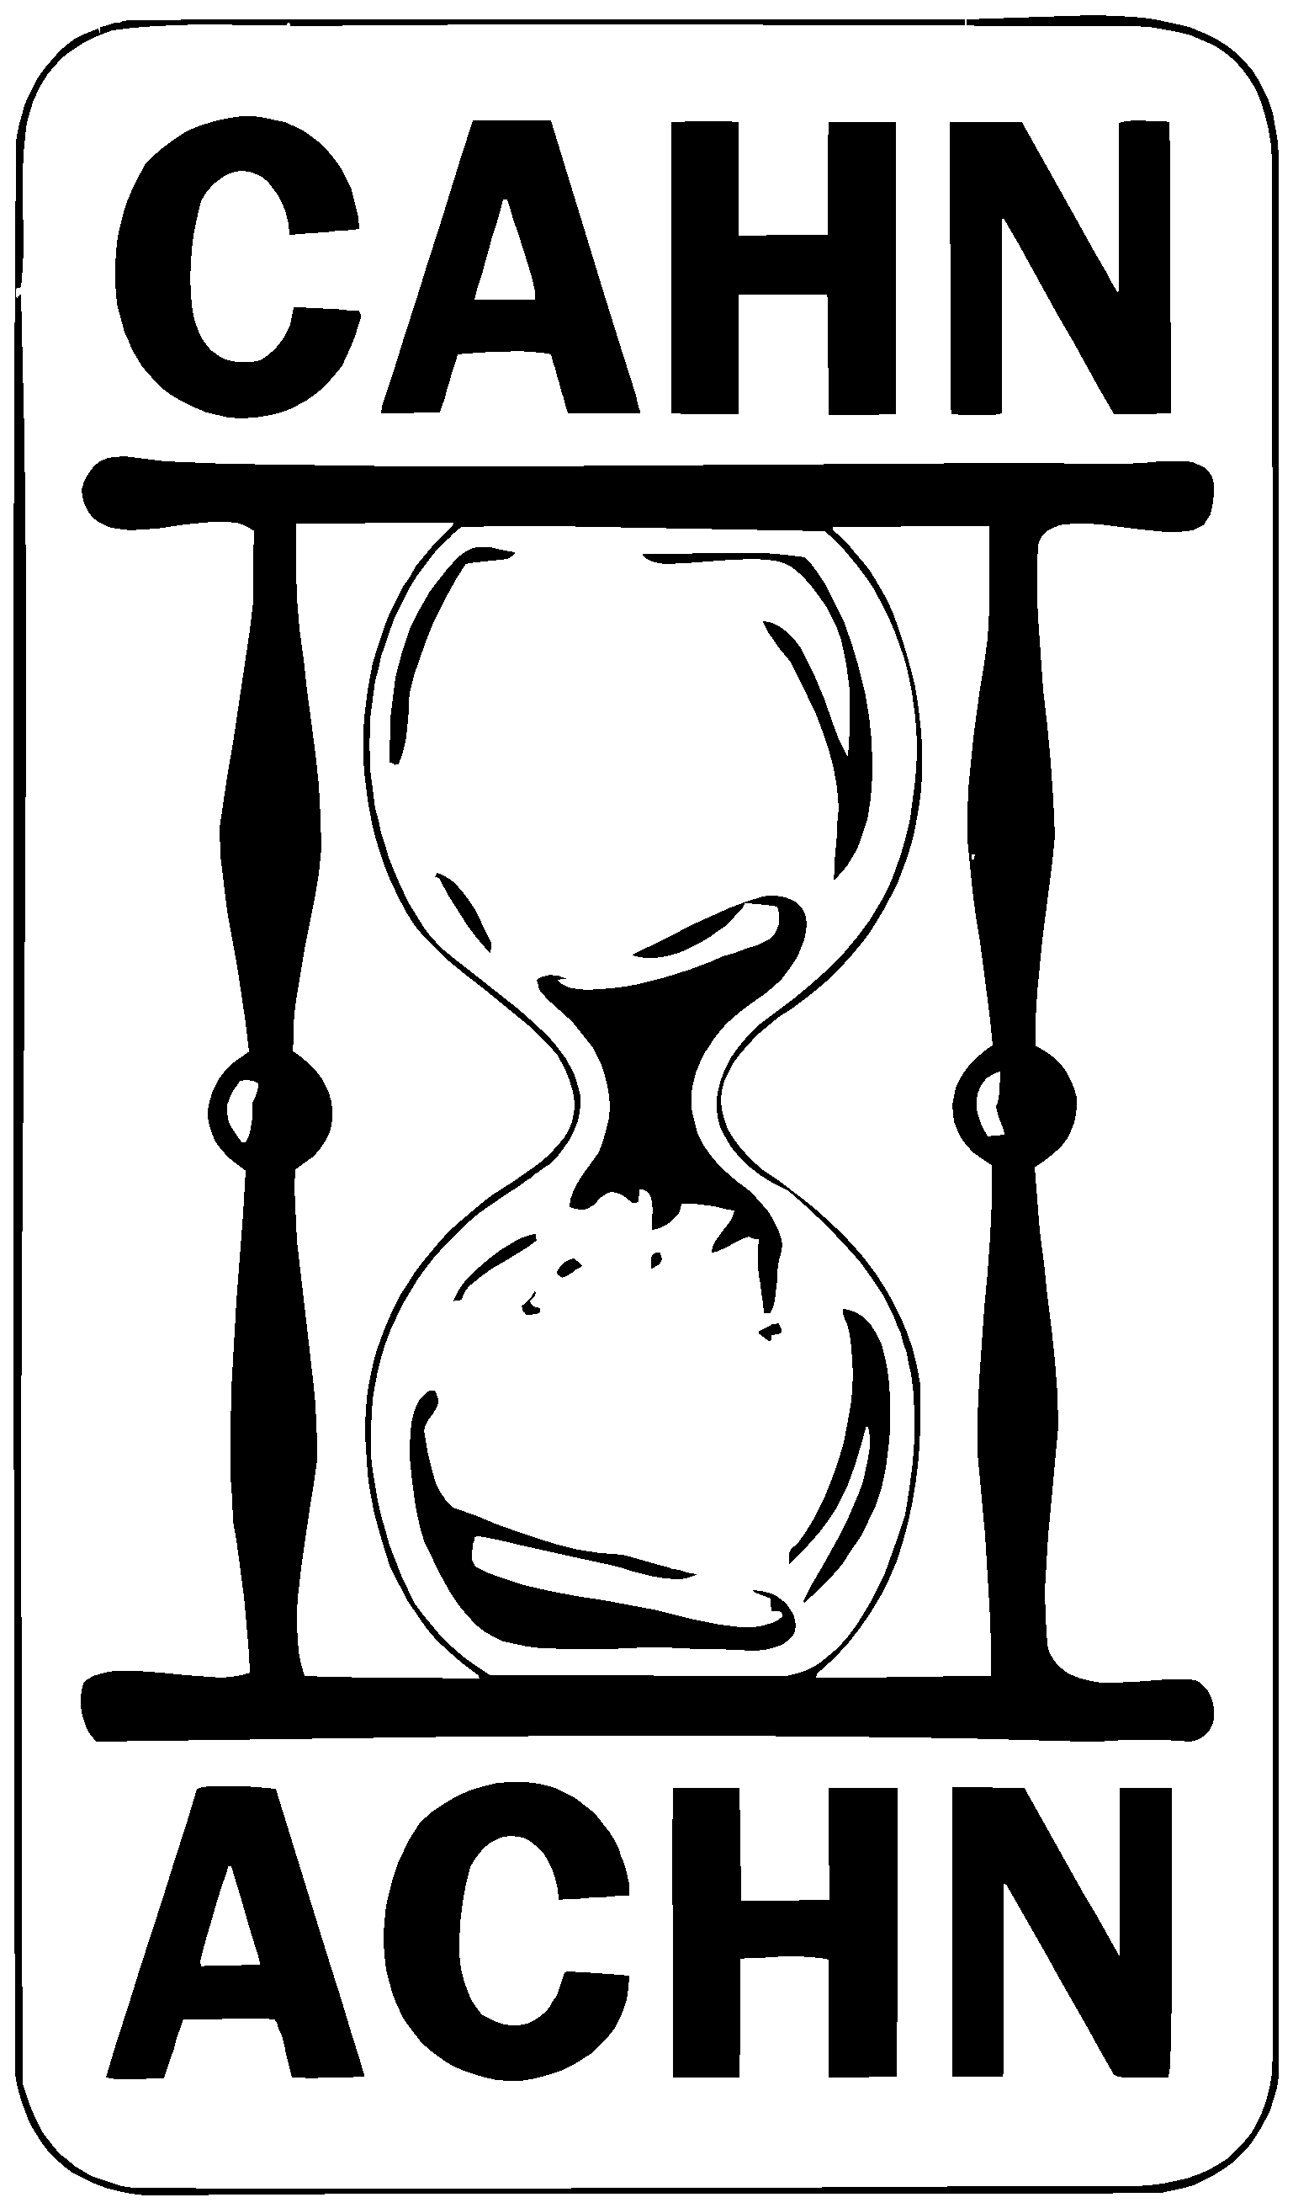

CANADIAN ASSOCIATION FOR THE HISTORY OF NURSING (CAHN)

ASSOCIATION CANADIENNE POUR L’HISTOIRE DU NURSING (ACHN)

CAHN/ACHN Dr. Margaret Allemang Scholarship in Nursing History

Purpose: To promote the study of Canadian nursing history among students.

Terms of Reference:
1). Scholarships will normally be awarded for study at the master’s and doctoral level.
2). Candidates must be studying Canadian nursing history.
3). Candidates must be enrolled in a university, and in addition, study within a recognized centre for the study of the history of nursing, or with a recognized Canadian nurse historian,
or within an university department of history, women’s studies, or other relevant department under supervision of a scholar with recognized expertise in or relevant to nursing history

Instructions: Please read carefully
1). Applications must be fully completed and signed (See below, Cover page and Proposal).
2). Application forms must be completed and submitted electronically (attached in email) to the CAHN-ACHN Awards Committee Chair by the 15th of April of the scholarship year. Submit two copies.
3). Please print name, address, and institution on one copy of the proposal only.
4). Applicants must provide proof of current enrolment in an educational program at a recognized university.
5). Applicants must provide a signed letter of agreement and reference from a qualified supervisor who supports the study, including a brief comment on the student’s programme of study
6). If granted the scholarship, applicants must acknowledge the award in writing and return the funds if unable to use them for educational purposes.
7). Please submit completed forms electronically to: cahnachnawards@gmail.com

- Cover page (one page, print and scan for electronic submission)

A. Personal Information:

Name :( please print) ________________________________________________

Address: _________________________________________________________

_____________________________________________Postal Code__________

Telephone :( w) _________________________ (h) ________________________

E-mail: ______________________________________________

Educational Institution and Department in which study will be done: _______
__________________________________________________________________

Expected date of completion___________________________________________

Supervisor: (please print) _____________________________________________

Signature of Supervisor: _____________________________________________

Signature of Candidate: ______________________________________________

B. Proposed Programme of Study:

Write a brief description of the courses in history/nursing history to be completed as part of the programme of study.

- Proposal [As attachment or as a separate document - put your name on top]

Proposal for study: (submit cover page and proposal electronically, by email attachement). Text should be written in 12 pitch Times New Rom or comparable font, double-spaced)
Maximum 5-7 pages in length. Proposal should include:

1). Title of project
2) Scope and objectives of the study
3). Significance of the study and its contribution to knowledge
4). Questions for study
5). Methods of study and primary sources to be examined
6). Relationship to previous research and literature
7). Bibliography

