Places and People’s Health: Exploring Nursing in Diverse Contexts

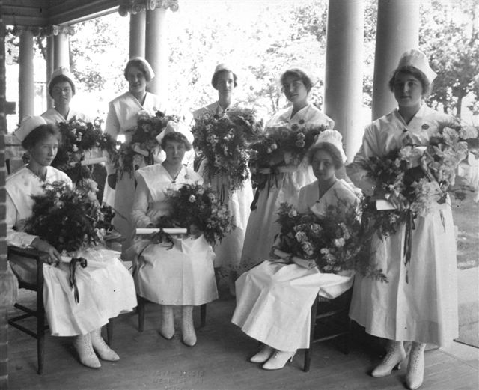

CAHN/ACHN 25th Anniversary Nursing History Conference
June 15-17, 2012, Medicine Hat, Alberta, Canada

CAHN/ACHN 25th Anniversary Nursing History Conference
2012 Program

Friday June 15th

5:00 PM - 6:30 PM - Board Meeting, Executive Boardroom C233

6:30 PM - Registration, Centennial Hall

7:00 PM - Opening Address, MHC Theatre

Welcome and Opening Remarks, Dr. Beverley Hicks, CAHN/ACHN President

Presentation of the CAHN Margaret M. Allemang Scholarship Award and the Vera Roberts Research Award, Beverley Hicks

2012 AMS-Hannah Lecture, Introduction, Judith Young

Carol Helmstadter, Adjunct Assistant Professor,
Lawrence S. Bloomberg Faculty of Nursing,
University of Toronto

“Military Nursing in Four Different Contexts:
The Crimean War, 1853-56.”

Reception to follow, Centennial Hall

This event is sponsored by the Associated Medical Services, Ontario, Medicine Hat RH/MHC Nursing Alumni Association, Medicine Hat College Division of Health Studies, MHC Conservatory of Music and Dance, and MHC Bookstore

*May be subjected to change

Saturday June 16th

8:00 AM - 8:45 AM - Registration and Breakfast, Cafeteria/Centennial Hall

8:45 AM - 9:00 AM - Introductions and Updates, MHC Theatre

9:00 AM - 10:15 AM - Session 1: Opening Session

Location: MHC Theatre Chair: Geertje Boschma

Jayne Elliott & Cynthia Toman, University of Ottawa
AMS Nursing History Research Unit

“Archives and Anecdotes: Telling the Story of CAHN/ACHN”

10:15 AM - 10:45 AM - Break

10:45 AM - 11:45 PM - Session 2: Canadian Nursing and Professional Identity

Location: MHC Theatre Chair: Florence Melchior

Michelle Filice, PhD Candidate, Wilfrid Laurier University
“Nursing in the Royal Canadian Navy: Exploring the Professional Identities of and Relationships between Sick Berth Attendants and Nursing Sisters, 1941-1945.”

Brandi Vanderspank-Wright, PhD Candidate, University of Ottawa
“Exploring Nurses’ Work in Canadian Intensive Care Units, 1960 - 2002.”

11:45 PM - 1:00 PM - Lunch, Cafeteria

1:00 PM - 2:00 PM - Annual General Meeting, Room S159

2:00 PM - 3:00 PM – Concurrent Sessions

Session 3A: Nursing and Medical History in International Contexts

Location: S159 Chair: Denise Hellman

Luciana B. Luchesi, Elaina Marcussi, University of Sao Paulo at Ribeirao Preto College of Nursing, and Fernando Porto, Federal University of Rio de Janeiro Sate School of Nursing, Alfredo Pinto, Brazil
“Possibilities for studying the newspaper in history research: The Faculty of Medicine of Ribeirao Preto, Brazil.”

Armstrong-Reid, S., Adjunct Professor, Department of History, University of Guelph
“Critical Reflections on the Ragged Edges of Post-Colonial Frames:
Writing the Creelman Biography”

Session 3B: Mental Health Care in International Contexts

Location: S103 Chair: Mary Jean Thompson

Claire Chatterton, Open University in the North West, Manchester UK
“Shifting boundaries in mental health nursing work: Breaching the ‘Great Divide’.”

Thomas Foth, University of Ottawa
“The war against madness: Nurses and shock-therapies in Germany, 1920-45.”

3:00 PM - 3:30 PM Networking Break: S-Wing Foyer

3:30 PM - 5:00 PM – Concurrent Sessions

Session 4A: Nursing Education in Historical Perspective

Location: S103 Chair: Lydia Wytenbroek

Luciana B. Luchesi and Margarita A. Villar, University of Sao Paulo at Ribeirao Preto College of Nursing, Brazil.
“Using games in teaching history of nursing: A Brazilian Perspective.”

Vicky Bach, Fraser Health, Abbotsford BC
“Bibs and Aprons: Recollections of Nursing in the 1930s.”

Sheila Rankin Zerr, University of British Columbia and BC Nursing History Society
“A Study of Two World War II Military Nurses: Hospital Training in the 1930s and Preparation for War.”

Session 4B: Public and Rural Health

Location: S159 Chair: Helen Vandenberg

Florence Melchior, Tanis Robinson, and Denise Hellmann, Medicine Hat College.
“The Spanish Influenza Pandemic, 1918-19: Experiences of Rural Canadians in the Prairie West.”

Carol Harrison, Northwest Community College, Terrace BC.
“A Passion for Prevention: Public Health Nursing in the Skeena Health Unit, 1937-97.”

Tara Tourloukis, Alexandra Marine and General Hospital, Goderich, Ontario.
“The evolution of mental health nursing in rural South-Western Ontario.”

6:00 PM - Dinner, Medalta in the Historic Clay DIstrict

Cash Bar, 6:00 PM; Dinner, 7:00 PM. Directions below.

Sunday June 17th

8:00 AM - 9:00 AM - Breakfast, Cafeteria

9:00 AM - 10:30 AM - Session 5: The Influence of Culture, Ethnicity, and Race

Location: MHC Theatre Chair: Margaret Scaia

David J. Kang, PhD Candidate, The Chinese University of Hong Kong.
“The Nurse-Nurse Relations: the Roles of Missionary Nurses and Chinese Nurses in the Establishment of Institutionalized Nursing System in Hong Kong, 1890s-1940s.”

Helen Vandenberg, PhD Candidate, University of British Columbia.
“The Establishment of the Japanese Hospital in Steveston, British Columbia 1880-1910.”

Lydia Wytenbroek, MA Student, Trinity Western University.
“ Relationships of Power among Clinic Staff: The Experience of WHO Nurse Margaret Campbell Jackson in Iran, 1954-56.”

10:30 AM - 11:00 AM - Break

11:00 AM - 12:00 PM - Session 6: Worthy Patients and Consumer Voice

Location: MHC Theatre Chair: Jayne Elliott

Geertje Boschma, University of British Columbia, and Marg Gorrie, British Columbia Institute of Technology.
“Engagement with the Development of Community Mental Health Care: Nurses’ and Consumers’ Views and Experiences.”

Margaret Scaia, PhD Candidate, University of Victoria.
“Situating the Grievable Patient.”

12:00 PM - Closing Address, MHC Theatre

“25 years of CAHN/ACHN - Looking Back and Moving Forward”

Closing remarks, Beverley Hicks

