CANADIAN ASSOCIATION
HISTORY NURSING
CONFERENCE
JUNE 15-17, 2018,in HISTORIC HALIFAX,NS
BETHUNE BUILDING, VG SITE
1276 South Park Street

HOSTED BY NURSING HISTORY NOVA SCOTIA SOCIETY
THEME:
“TRACING NURSES FOOTSTEPS:
Nursing and the Tides of Change”

REGISTRATION FEE: Regular all-inclusive $230 plus tax
Students $115 (excluding dinner) plus tax
APPLICATION FORM - PROGRAM INFORMATION
and anything else you need to know
WEBSITE: https://cahn-achn.ca/annual-conference-2/
COME AND MAKE A SPECIAL HOLIDAY;
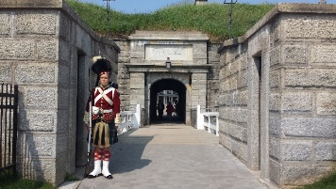
HALIFAX HISTORICAL SIGHTS; NOVA SCOITA OCEAN PLAYGROUND; EASTERN HOSPITALITY; BEST SEAFOOD EVER—AN EXPERIENCE YOU WON’T FORGET !\

-------- Besides an interesting conference ---------

