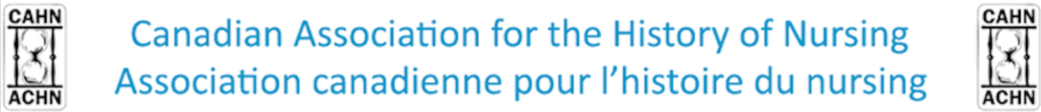
Photovoice Contest
CAHN Annual Congress
Ottawa 2020
As part of the Canadian Association for the History of Nursing’s annual congress, the organizing committee invites undergraduate to PhD students registered for the congress to participate in a photovoice contest on the theme “Care in Conflict: Healthcare under Tension.” Two $200 scholarships will be given, one to the undergraduate winner and another to the best submission from Masters and Doctoral candidates.
What is a photovoice?
A photovoice is generally defined as a participatory research approach. It is used to document and reflect the reality of a community or an individual regarding a specific issue. In a photovoice, “[p]hotography is a medium of language that is universal in its appeal. Minimizing language and cultural barriers, it reflects a reality as seen and experienced by an individual and a community (Wang & Burris, 1997).” The historic and interdisciplinary sensibilities are used here to make an image talk. This image can come from archives, photo albums, or directly from students. We chose this method to make history and nursing students reflect on the conference theme in an unconventional way and to allow them to express and exchange original ideas on tensions in healthcare.
Participants can photograph a scene or an object that represents well the issue that they are discussing and then add a short text reflecting on the image and analyzing it (see the example below). The image can also be taken somewhere else if it is royalty free. To guide their reflexions, students can build their photovoice around the following questions:
- What do we see?
- What does the image suggest?
- How does it relate to the theme?
Format and instructions
- JPEG, 1920 X 1080 pixels, 72 ppi
- Powerpoint support
- Participants must model their photovoice on the template proposed below
- Participants must find a title and indicate their school affiliation (see template)
- Text must be between 180 and 230 words
- Font size: 96 for the title and 55-60 for the text (Times New Roman)
- Image must be royalty free (see the consent form if using somebody else’s image)
- Template size : 90 cm X 120 cm (landscape format)
Theme
The submissions must be oriented towards the theme of the congress: “Care in Conflict: Healthcare under Tension.” In other words, how are tensions and conflict expressed in health in different eras, or under different circumstances? Your submission can be inspired by, but not restricted to, the following ideas.
- Social and economic tensions (hierarchy and status; marginality and minorities; urban and rural disparities)
- Identity conflicts (social norms; gender; sexuality; ethnicity; language; religion)
- Diagnosis
- Care
- Interdisciplinary tensions
- Hierarchies and work/labour divisions
- Tensions within the different fields of nursing
- Conflicts surrounding practice redefinitions
- Unionization
- Professional recognition
- Disciplinary tensions and conflicts
- Intergenerational tensions and conflicts
Evaluation criteria
- Relevance of the chosen photography and connection to the theme (justification)
- Clarity of the whole document
- Logical organisation and overall coherence (between image and text)
- Originality
- Quality of the comment and reflexion on the theme
- Language quality
Date
Photovoice propositions must be sent to the committee for preliminary evaluation to the following address : marie_lebel@uhearst.ca before 4 pm, April 24, 2020. Once the committee reaches back to confirm participation to the contest, it is the student’s responsibility to print her/his photovoice and to make sure it respects the template. The photovoices that pass this preliminary evaluation will be displayed during the 2020 CAHN annual congress.
Note: The preliminary evaluation will determine whether or not a photovoice kept. The committee reserves itself the right to refuse any submission that does not conform to minimal presentation norms (language, references, etc.).
Model and template
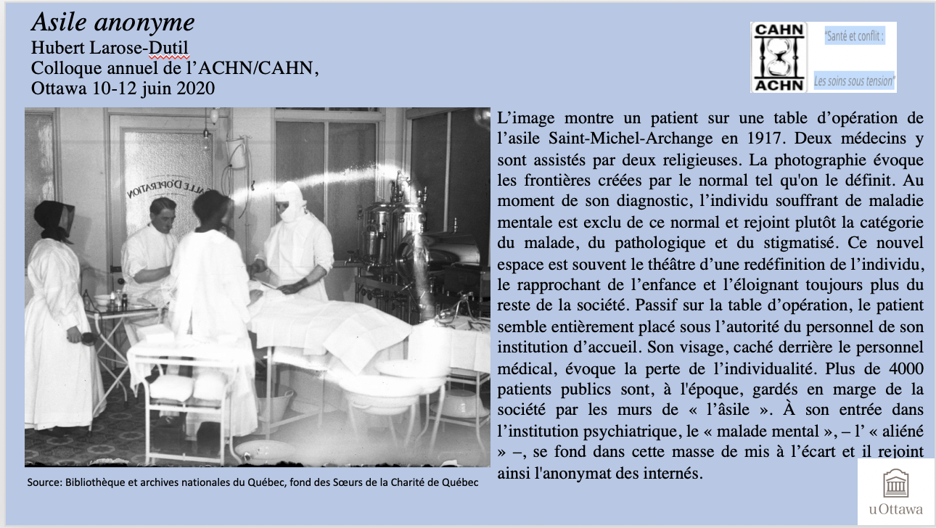

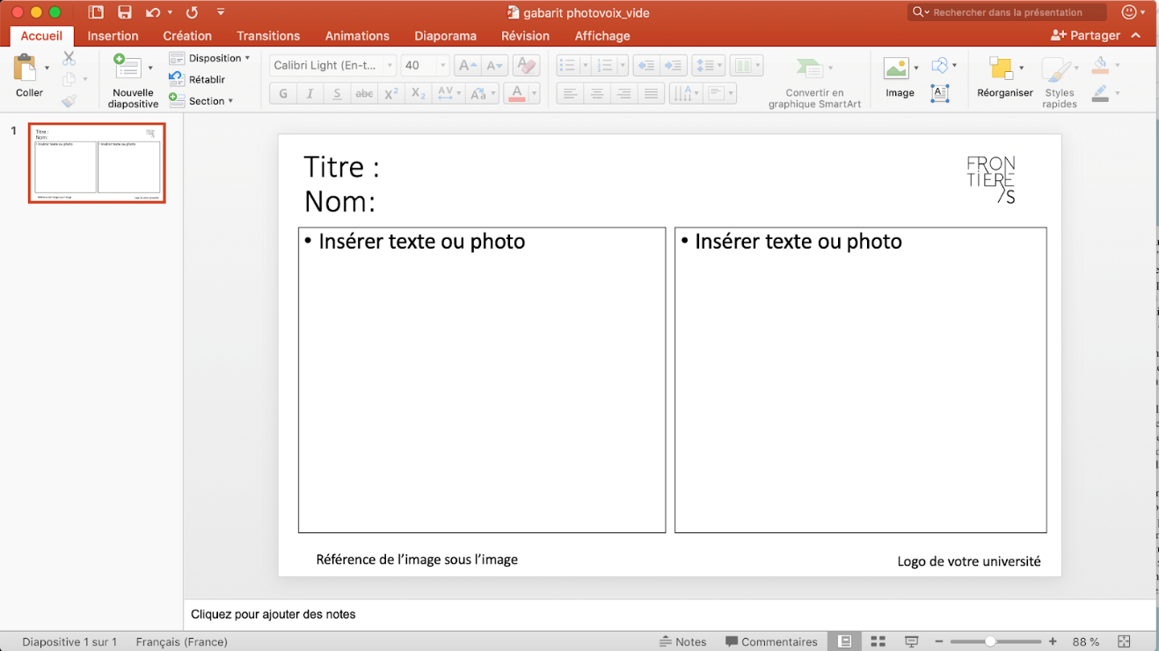

Photovoice CAHN/ACHN
Annual congress, june 10th-12th, 2020
Ottawa
Inscription form and authorization of use
Last name______________________________

First name______________________________

Title of the photovoice: ______________________________________________________

School affiliation ______________________________________________
- Studies cycle :
  - Undergraduate
  - Masters
  - PhD
Field of study or discipline: _________________________________

Participation to this contest gives the Canadian Association for the History of Nursing and its representatives the right to use your photovoice to promote or display future contests.
I have read and accepted the terms listed above:
Signature ________________________________________

Date _____________________________

