Archives and Anecdotes: Telling the Story of CAHN/ACHN
Presented by Jayne Elliott and Cynthia Toman, June 2012

BEGINNINGS
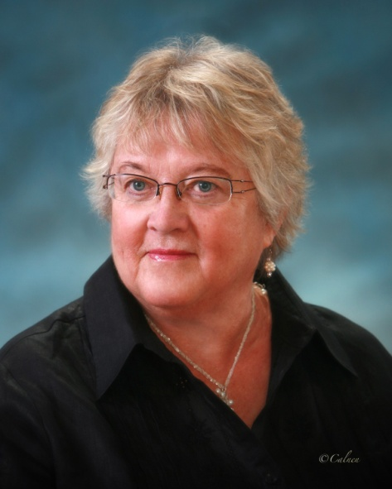
Immediately after graduating from the school of nursing in Yarmouth, Nova Scotia, Barbara Keddy was asked to become a clinical instructor in the program. Although one of the courses she taught was on the “history of medicine” (rather than the advertised nursing,) it was more or less a “rote thing” of memorizing dates, etc. Moving later to Halifax with her young family, she completed a diploma of public health nursing, a bachelor of science in nursing, and a Masters in sociology. As she began her PhD in sociology in 1977, she landed a job teaching in the school of nursing at Dalhousie. Although no courses on nursing history exist at Dalhousie, then and now, her own interest in the history of nursing was sparked when she began talking to some of the older nurses in her program about the changes in nursing they had witnessed. With funding from the Registered Nurses Association of Nova Scotia, she travelled the province conducting oral histories with nurses who had graduated from the 20s to the 40s, eventually placing the transcribed tapes in the Nova Scotia archives. When a radio station “read or heard of some of my interviews … they started putting them on the radio station and it just became something of a passionate interest of mine. As a feminist in the school of nursing with graduate degrees now in sociology I was somewhat marginalized. I wondered how I could bring about a relationship with some organization that was interested in nursing but also would have a different perspective than just merely nursing theory.”
Figure 1 Barbara Keddy

By now it was 1986 and Keddy and her husband were preparing for a sabbatical in England. Realizing the growing public interest in the stories told by the women in the tapes, and wanting them to go beyond Nova Scotia, the “idea came to her” that it would be “wonderful” to have an association for the history of nursing. A library search produced the name of Monica Baly and the nursing history group associated with the Royal College of Nursing in England. Keddy wrote to Baly and asked if she could visit her to discuss how to set up something similar. At the same time, she came across the name of Margaret Allemang and asked her if she could meet with her in Toronto before heading off to England.

Born in 1914 in Toronto as one of a set of twins, Margaret Allemang had battled osteomyelitis in her early days that considerably delayed her high school graduation. Considering it “out of the question” that she would be accepted in a hospital nursing school, at age 22 she entered the School of Nursing at the University of Toronto after an interview with Kathleen Russell, who didn’t seem worried about her previous health and “decided that my background was worthwhile academically.” Graduating in 1940, Allemang left her first job as assistant head nurse on a cancer ward at Toronto General for enlistment in the Royal Canadian Air Force, where she served for three years at air force hospitals in Ontario and Alberta. With funding from the Federal Re-establishment program, she returned to U of T, completing both a BA and a BScN. After two years teaching nursing in Belleville, she returned to the nursing program at U of T, where she stayed for the rest of her career.
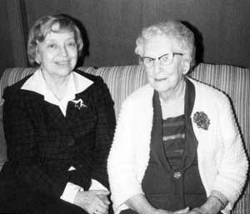
During this time she obtained her MA (in the 1950s) and her PhD (in the 70s) in education from the University of Washington in Seattle. Unable to get her committee to approve her first interest for her dissertation in developing a nursing theory based on existentialism, she eventually settled on studying the history of nursing education in Canada and the US through the ideas of a group of influential nursing leaders. U of T as well lacked a formal nursing history course in its curriculum, and her attempts to get research funding for a specialty in nursing history went nowhere. Stimulated as well by the idea of doing oral history, Allemang maintained her interest in things historical by interviewing nursing sisters, first from the First World War and from the Second.
Figure 2 Margaret Allemang (l) with FWW Nursing Sister Mabel Rutherford, 1978

“… And then of course there was the visit from Barbara Keddy, from Dalhousie, who just got in touch with me once and wanted to know if she could come and see me. And she was passing through Toronto on her way to England so we met down at a hotel and had muffins and coffee and brought up the subject of [having] … an organization, a national organization for nursing history. And I thought it was a good idea … I had already thought of doing something more advanced in nursing history … Barbara’s idea was very exciting to me and we decided to go ahead with this emphasis on organizing across Canada.”

Keddy too had been inspired by her visit with Allemang in Toronto – “she generated a lot of excitement within me.” Monica Baly had also told her: “you know, you Canadians, you can do anything you want to and you don’t have to model yourself after [anyone] … if you want to do it, just do it. By 2 July 1986, she had written to Allemang, expressing the hope that would become a “‘founding’ member along with me.” She began to think about how they could work collaboratively in what needed to be done in creating a new organization: compiling a list of potentially interested people, drawing up a constitution, based perhaps on that from Monica Baly’s group in England, choosing a name, and deciding whether or not they should become an interest group of the CNA. By this time Allemang was retired and unable to access the same administrative resources available to the still-working Keddy, who also owned an electric typewriter! Admitting later that she had been unfamiliar with the concept of networking, she nevertheless joined Keddy in contacting friends and colleagues for their responses to forming a national nursing history association and asking for the names of other people who might have a possible interest in this new association.

In the fall of 1986, Allemang attended the third annual meeting of the American Association for the History of Nursing on the invitation of Barbara Brodie (who is still active) in order to learn about the organization and concerns of that group that might have an impact on the formation of a history of nursing group in Canada. Funding was the primary issue confronting the American Association, making the establishment of a full journal seem “premature,” and raising concerns that the proliferating number of American history of nursing organizations was too much duplication of effort. Allemang adroitly sidestepped one member’s query about why the Canadian organization didn’t just become part of the AAHM; she argued that we “needed to search and discover Canadian nursing’s own unique identity” which “seemed to point to a Canadian nursing history association.”

Letters flew back and forth between Allemang and Keddy during that fall, trading information about names and responses from contacts they had made. Natalie Riegler wrote in October that “the desire for a Nurse Historian / Writer Association must be in the air,” for she had just contacted Judith Young, Meryn Stuart, and Lynn Kirkwood about meeting at the RNAO annual meeting the next spring. Isabel McCrae believed that the structure should be less formal - preferring the format of an “interest group” that would remain “just that, and not turn into a power base for some ‘hungry’ academics.” Irene Goldstone believed that a formal structure was indeed necessary in order to access funding for the “urgent issues” of archiving the documents and lives of early nursing leaders. Shirley Stinson proposed something in the middle; with some kind of national nurse researcher organization soon to emerge, she thought, she advised that forming a steering committee would help move things forward but would not prematurely determine the permanent structure of the group. Allemang and Keddy also continued to debate the pros and cons of close ties with CNA – they recognized that there might be benefits to a fledgling organization for the use of meeting facilities, seed money, and visibility from a mature organization, but they also did not want to exclude non-nurses and they were not getting any encouragement from anyone at CNA about becoming a nursing archives or artifacts repository, either in general or for the new association.

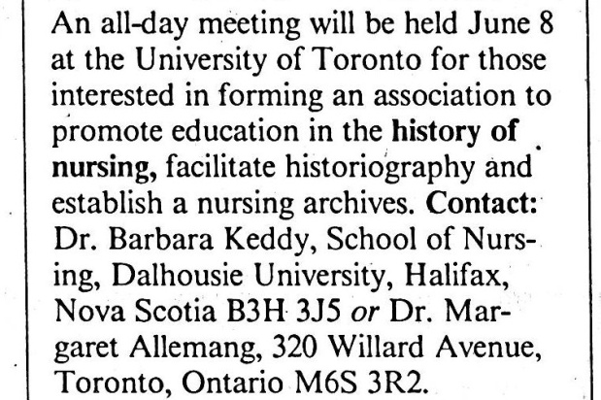
By December 1986, Barbara excitedly wrote, “it is becoming rather difficult for us to keep up with one another as developments evolve! My file is now thick and we will need to write a history of the history of nursing group!” It was clear now that an initial meeting was in order. They prepared an information notice for the May issue of the Canadian Nurse and other provincial nursing bulletins, and notified all of their contacts. Although they were determined not to be seen as “Ontario-centric,” Keddy believed that more people would be able to come to a central location and she was sensitive to saving costs for Allemang. With expectations of about 30 attendees out of the by-then almost 100 responses, they scheduled the first meeting for 8 June 1987 in the Jean Gunn library at the University of Toronto.
Figure 3 Canadian Nurse 83 (May 1987): 41

Twenty-six interested people joined Allemang and Keddy at the all-day meeting that Monday in June, representing Ontario, Alberta, Quebec, Saskatchewan, New Brunswick, and British Columbia. Many more had written to say that they were interested but unable to attend.

Barbara Keddy remembers a distraught Helen Mussallem bursting into the room after the meeting had started, exclaiming that although “I have travelled all over the world my entire life, I just took a little plane from Ottawa to Toronto and I thought we were going to die, we were hit by lightning!” After discussing the desired aims and objectives, adopting the name, and deliberating on whether or not to become a CNA interest group, the rest of day was spent brainstorming in small groups on refining the objectives, setting membership fees, sorting out the organizational structure, and deciding on the various activities that the new association would undertake in the coming year. Other committees formed to work on the constitution and by-laws, nominations and program over the following year. Keddy began to realize that “because of the expertise in the room that this was not going to be an easy thing to … I should have known – if you’re in academia you know that people are always looking at philosophies and all these other kinds of statements and objectives and this kind of thing … But the people there … were so extraordinary …There was just so much expertise there that we were able to parcel out the responsibilities.” Before breaking up for the day, they also chose a provisional executive, naming Keddy and Allemang as president and vice-president, respectively, Natalie Riegler as secretary, and Jean Sillars as treasurer.

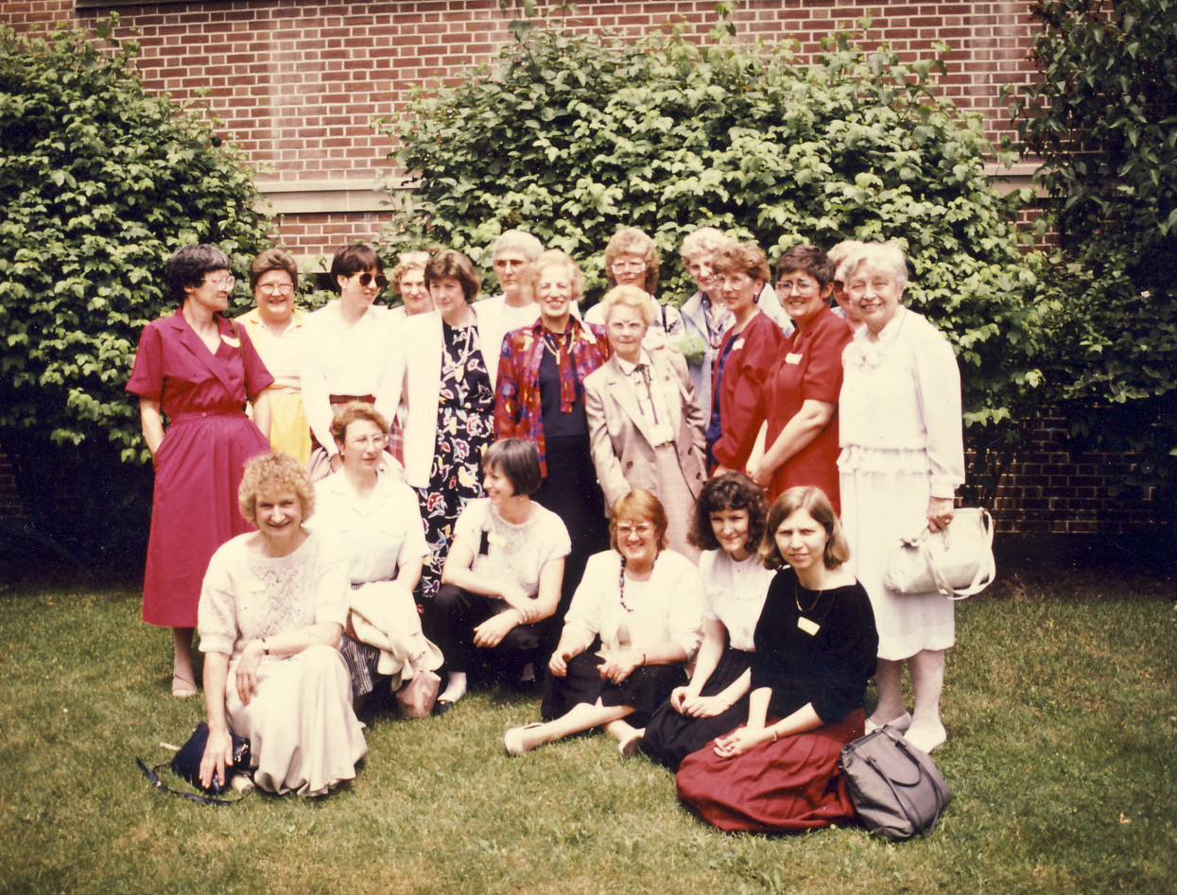

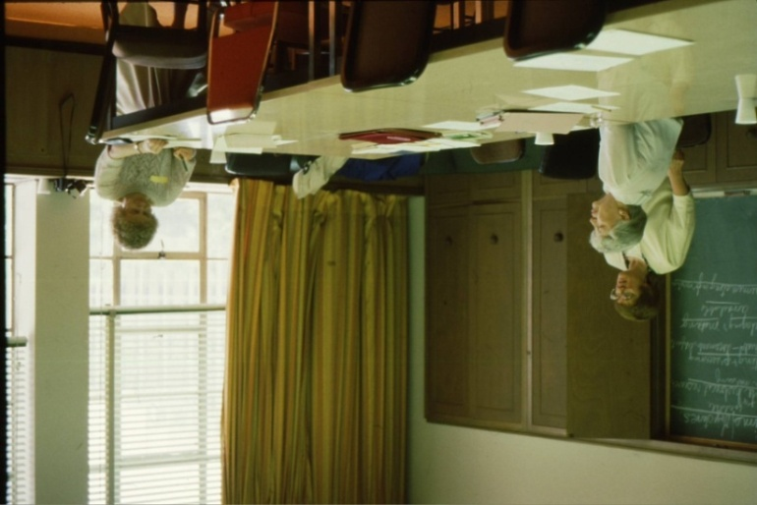

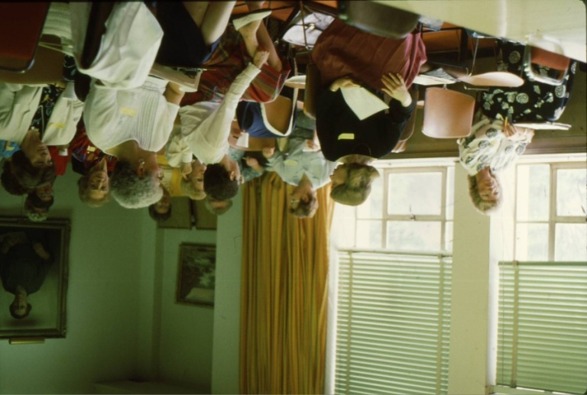

Plans were then underway to prepare for the first conference, to be held in Charlottetown, PEI, to coincide with the CNA general meeting there. Allemang had agreed to be conference chairperson, and Keddy wondered recently “how on earth Margaret became the chair of that … that poor woman … I mean we all helped her but she was the chair of the whole program – the whole conference – and that was quite a chore for somebody who didn’t have access to the kinds of resources that people who were working had.” Allemang agreed that the first program had been quite a bit of work – no one in PEI was “interested in history,” and all communication had been done by long distance with the people at the hotel.

Monica Baly, who had followed the birth of CAHN with interest, agreed to be the keynote speaker. Allemang had previously received a grant from the Hannah Institute (Associated Medical Services) for her own oral history project and now succeeded in persuading executive director Dr. Robert McBeth to provide funding to bring Baly to the conference. The program was packed - speakers were scheduled on June 16 every 15 minutes from 9 am until the early evening. Lynn Kirkwood remembers that it was indeed a long day but that “Marg was just beside herself with joy. It was like a Christmas present for her to have it finally happen.” Natalie Riegler commented that Baly had done a “tremendous summary” at the end of that day and compared the session to “Nightingale days because we went from dawn to dusk.” Allemang, who had been trying to follow the procedures and standards of the AAHN’s programming, agreed that perhaps she “had overdone it a little bit.” But Keddy recalled that it “was really successful and we were really excited.” Baly, who had also been impressed with the caliber of the talks, paid them the ultimate compliment when she told Keddy that the presenters were much more research oriented than her own history of nursing group in England.

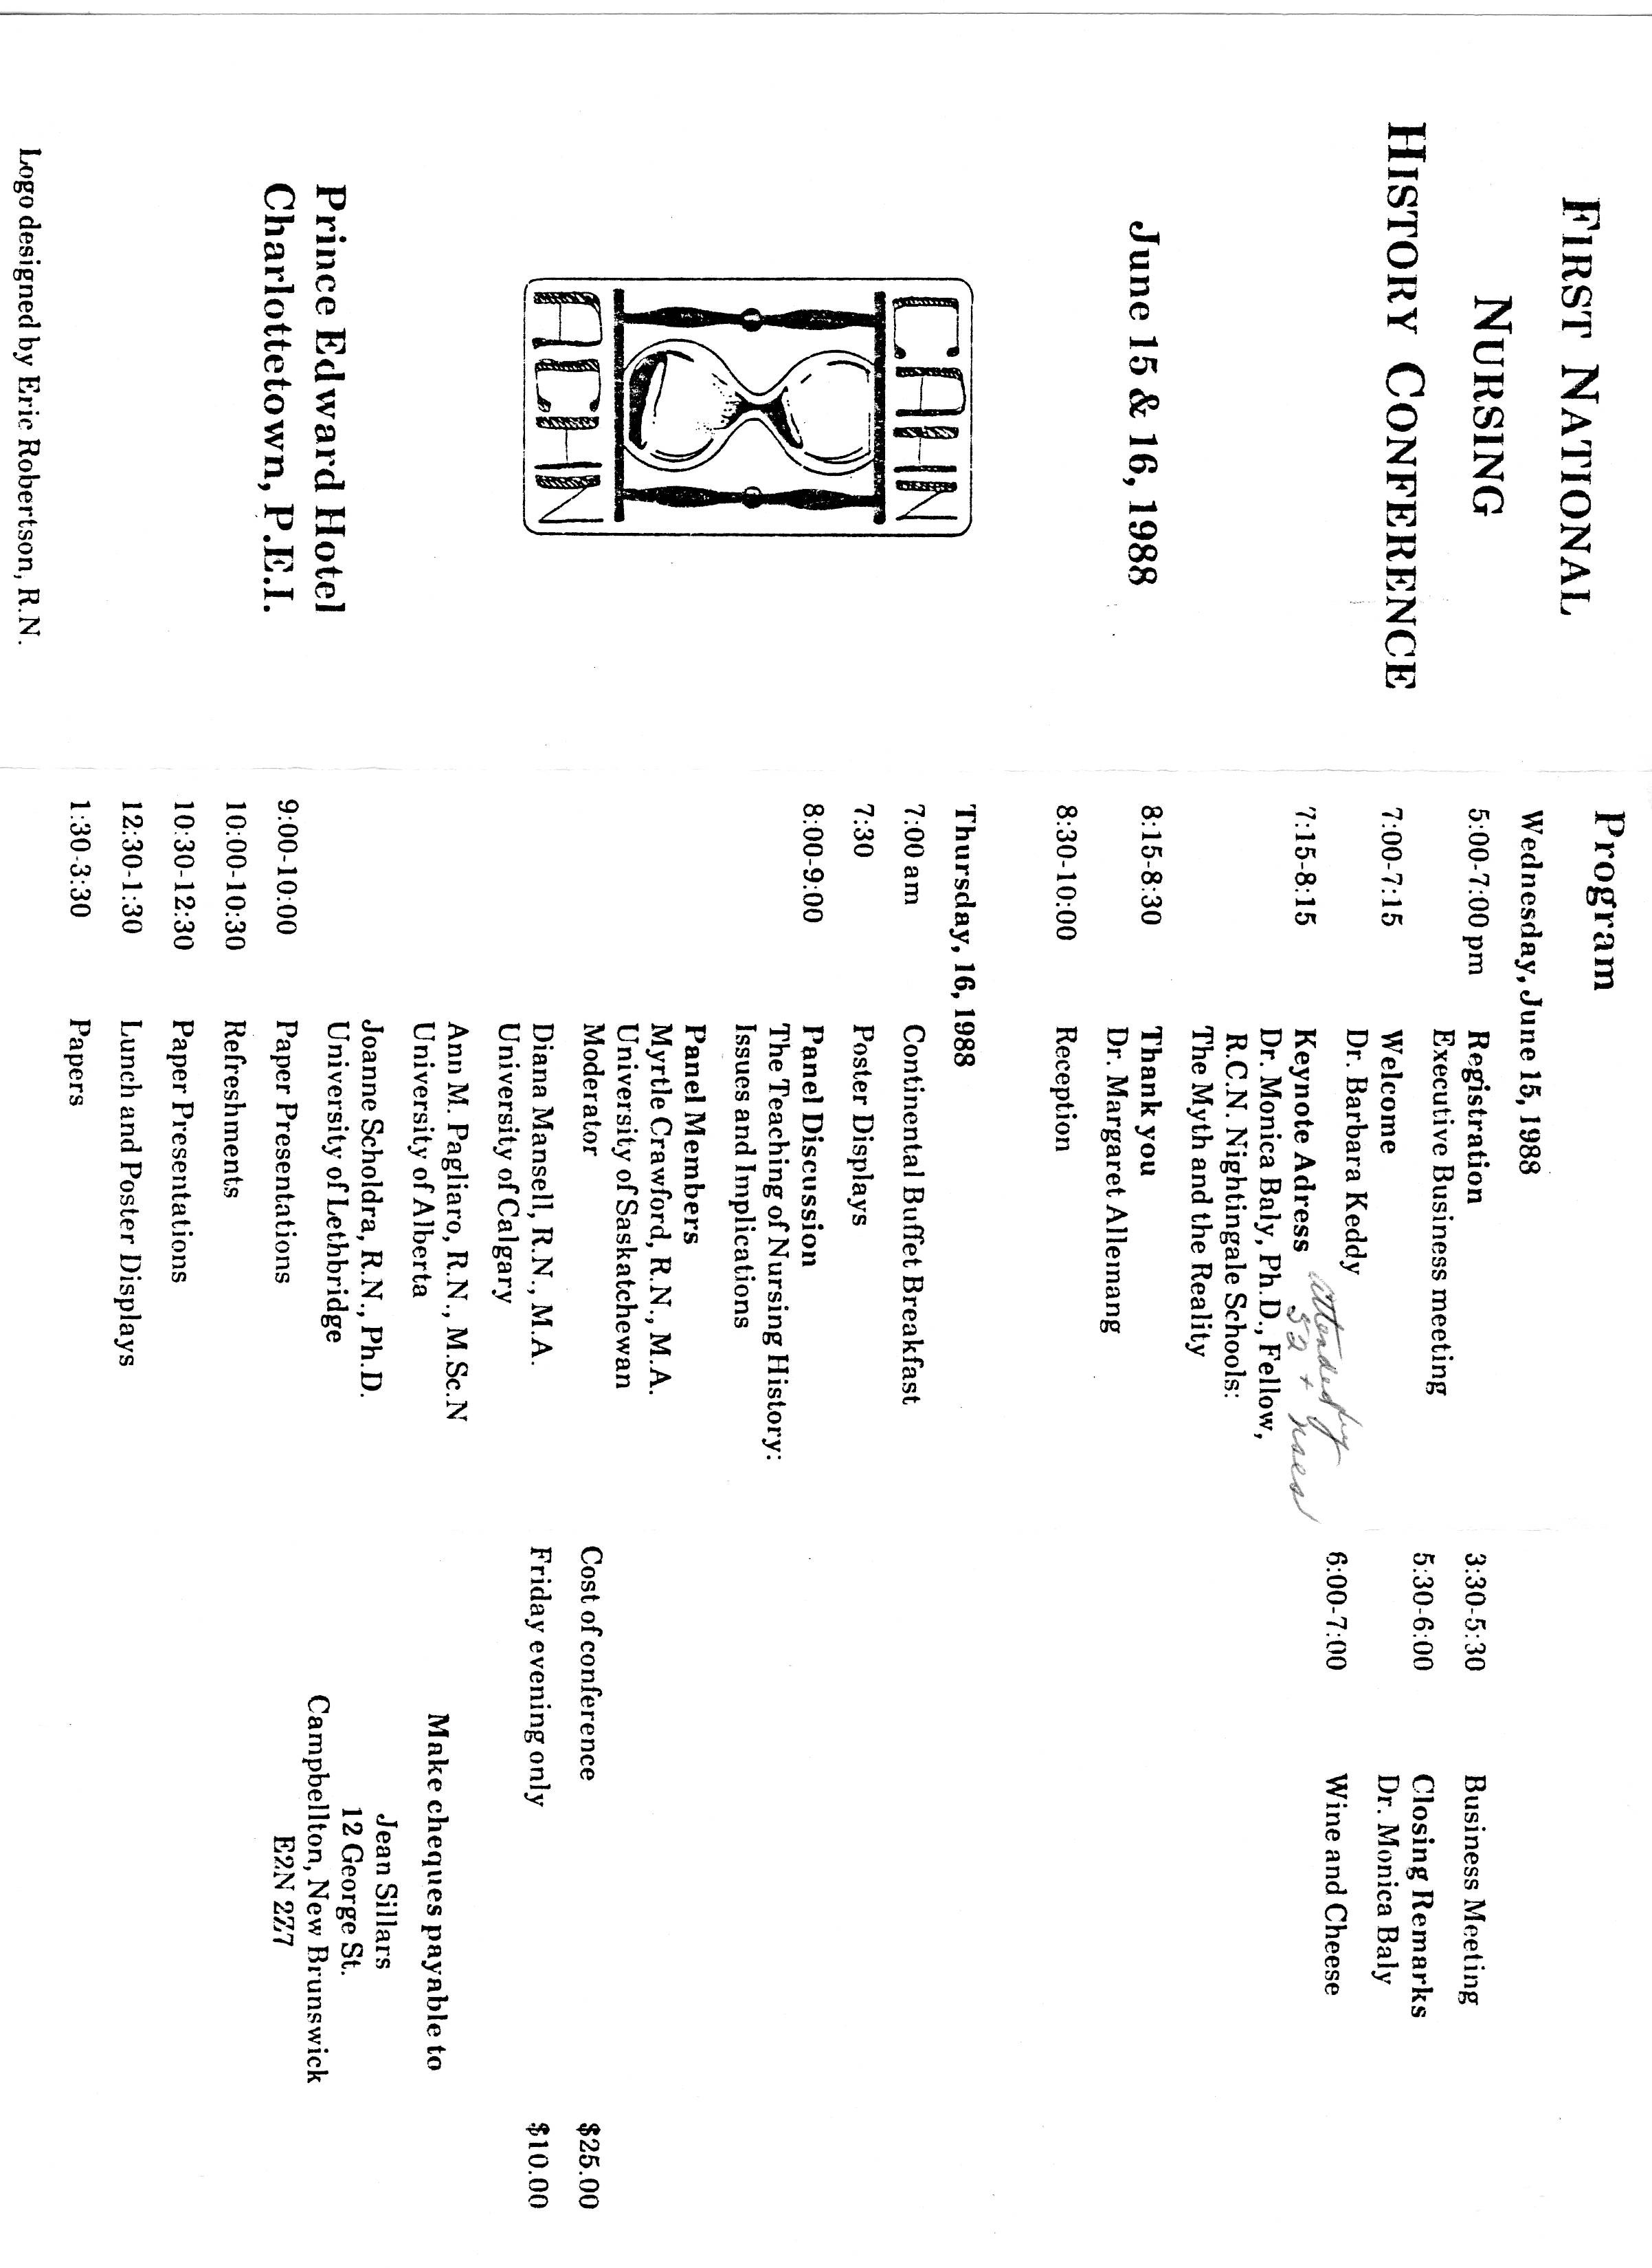
In her provisional president’s report, Keddy outlined the status of the new association. The membership form had been translated into French and paid-up membership stood at a very respectable number of 100. Keen members of her Dalhousie research class had compiled a bound history of the association so far, and Eric Robertson, one her post-RN students who was also a commercial artist, had developed a logo that she hoped would be officially adopted at the meeting. She had framed the signatures of the charter members and had asked Allemang to hang them in the Jean Gunn Memorial Room at U of T. Because of the volume of correspondence and mailing costs, the newsletter had not yet begun, but a proposed constitution and by-laws had been sent out and a lawyer had been consulted regarding incorporation and attaining charitable status.
Presenters at First CAHN Conference
Charlottetown, PEI
Janet Kerr
Joyce McQueen
Marilyn Marsh
Margaret Allemang
Barbara Keddy
Natalie Riegler
Katherine Arnup
Meryn Stuart
Judith Young
Karen Hanson, Patricia Lingley, B. Keddy
Marilyn Steven
Judith Hibberd
Sharon Richardson
Jocelyn Hezekiah
6 poster presentations

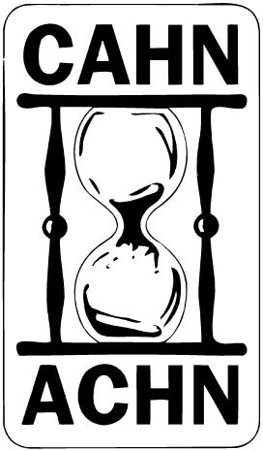
These auspicious beginnings thus launched the association. Although the care of nursing archives and artifacts was of a primary concern, both Keddy and Allemang had high aspirations for promoting historical research. Despite their obvious compatibility – “we got along famously, fortunately,” Keddy wrote, “and complemented each other” – the two came to history from different directions and philosophies. Since her own training had been in sociology, Keddy admitted that had she come “into history through the back door.” But she also had a “hidden agenda” that she kept hidden even from Allemang. She felt marginalized in the 70s and 80s in her own nursing department because of her feminist leanings, and she initially wanted this new association to be “a place where feminist women could get together and talk about the issues from the past that were gender- and class-related.” She confessed that she struggled awhile in finding her grounding: “how do you do historical research and how do you do an analysis and how do you incorporate gender into it without just reporting? Allemang had perhaps more experience in historical research and methodology because of the content of her doctoral thesis. She believed that history was not a “frill,” and she wanted the organization to become “deeply rooted … and understand the writing of history.” Her view of history was based on the ideas and analysis of “continuity and change,” whether in nursing practice or in “intellectual ideas.” But, “just to focus on gender and oppression” was “too confining,” for her -- feeling that nursing was being “forced into the concept of oppression” by such an approach. Nonetheless, their academic backgrounds had given both founders the vision and experience to put toward guiding the early development of the association and they wanted the meetings to measure up to the standards of any other nursing research conference.
Figure 4 Designed by Eric Robertson, post-RN student of Barbara Keddy, 1988

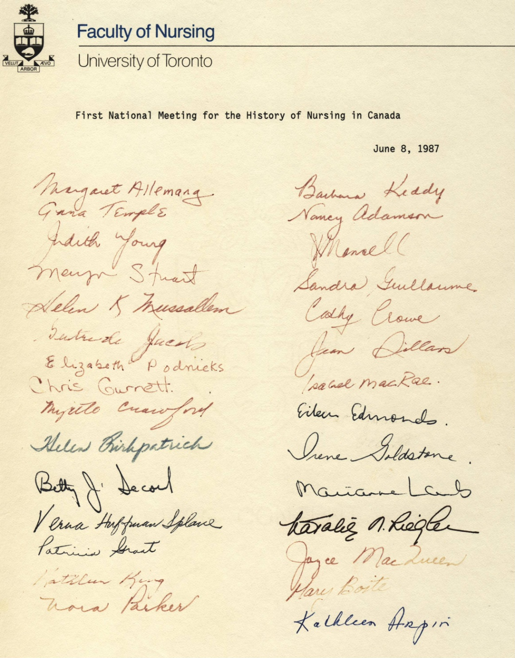
THEMES
Preservation of sources/ Production of new research
The identification and preservation of archival sources was very much a high priority item throughout the first decade, partially as a starting point to do historical research since nurses have traditionally left so few official records and documents – a recurring theme within organizational history. Indeed archivists were keynote speakers at both the 1989 and 1993 conferences. Kathryn McPherson and Barbara Craig were warning that the closing of hospitals and the increasing neglect of local archives was putting many of our healthcare sources in general at risk. The executive encouraged the formation of local and provincial groups to help facilitate saving archives. Not all provinces were successful; the number of nurses interested in nursing history in the Maritimes was never very large, as Barbara Keddy and Anne-Marie Arseneault both pointed out. Still, the Ontario Society for the History of Nursing, the forerunner of the present-day Margaret Allemang Society, was thriving, and in the fall of 1989, Glennis Zilm reported on two nursing history groups in Vancouver and at the RNABC. “Something in those invigorating ocean breezes” commented Diana Mansell, then the newsletter editor.

The BC History of Nursing Group in particular has had (and still has) a major impact on the preservation of nursing history sources there, and has as well made them accessible for others. Along with BC, groups in Alberta, Ontario, Quebec, and New Brunswick tracked down and published the holdings in individual provinces. Diana Mansell canvassed public and private archives across the country and in 2002 published her invaluable resource on the location of nursing history sources nationally.

Published Sources on Nursing Archival Material
- Coles, Survey of Nursing History Materials in British Columbia (1990)
- MacMillan & Young, A Guide to Nursing Historical Materials in Ontario (1994)
- Mychajlunow & Richardson, A Directory of Nursing Archival Resources in Alberta (1996)
- Bramadat and Saydak, Catalogue of Nursing Historical Photographs in Manitoba (1996)
- McGee, A Guide to Health Care History Material in New Brunswick (1998)
- Mansell, Guide to Canadian Nursing Archival Resources, (2002)

From 2003, CAHN members have used both their organizational and individual influence to engage politically for the preservation of CNA historical artifacts and records when CNA broke up its library. One amazing outcome of the efforts at preserving the CNA collection was the first national exhibition on Canadian nursing history – The Caring Profession – which ran for 15 months at the Canadian Museum of Civilization in Ottawa in 2005-2006. Over 170,000 people viewed this exhibit – an unforeseen window of opportunity to showcase Canadian nursing history.

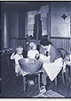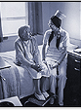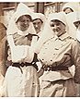
But members have not just preserved sources, they have also created them. Several have conducted oral histories of significant numbers of Canadian nurses that have been deposited in various archives. As one example, Arlee McGee created the Nursing History Resource Centre at the Nurses Association of New Brunswick in 1992 that on her death in 2003 was moved to the Museum of New Brunswick in St. John. These archives were useful to Linda Kealey and others for research on the large recent project to document women and labour in that province.

Since around 2000, however, CAHN’s activities have moved more towards reporting on the production of new knowledge. We have the two awards that CAHN provides, and notices of speakers presenting nationally and internationally. This is not to say that good historical research was not being conducted or presented before. As you recall, Monica Baly was so impressed with the scholarship at the very first meeting in PEI, and asserted (confirmed by Keddy) that it was much better than what was going on in her own group in England. Marion McKay, among others, also believes that the level of scholarship at CAHN meetings was until recently higher than at the CSHM.

What Kind of History?
What has surfaced now and again during the life of the association is “what kind of nursing history should be done.” Organizations devoted to the history of professional groups and their interests have a tendency to generate some turf conflict between those who are members trained in the profession and those who are academic historians writing about the profession – what has been called “insider vs outsider history.” Aided by the burgeoning interest in social history and in “doing history from below,” occasional acrimonious debates took place in the 1980s, for example, between historians and physicians, who publicly argued over who had the legitimate claim to write about the history of the medical profession. From the very first, CAHN/ACHN attracted members simply interested in history as well as those with graduate degrees in other disciplines who were undertaking historical research, and those who were academically trained historians deeply involved in nursing history. For the most part, however, they have all been nurses, although CAHN has always wanted to be inclusive – part of the angst over whether or not to become an interest group of CNA was the desire not to exclude non-nurses. Thus, the types of “growing pains” experienced by some other organizations have perhaps been more muted.

Nonetheless, a strong debate over a proposed “workshop retreat” in Regina instead of a regular annual conference unleashed a spirited discussion. In 1992, new president Ina Bramadat wrote that “although we are proud of our growth, we are still searching for our identity.” She summarized the questions that had been raised: Should conferences “focus on scholarly papers or might there be workshops for members who want to learn more about the research process? Are we secure enough to accept critique of our research? Does our annual conference need to be scheduled to follow the conferences of larger associations, or can we survive as a free-standing body? Is there a place in the Association for those who are interested in preserving and relishing the heritage of nursing as well as those who are more academically inclined?” To her, the “strength of CAHN /ACHN [lay in its] ability to meet the needs of all members, to strike a balance between the interests of our career-oriented researchers and those who have a broader interest in nursing heritage.” And it must have been quite the meeting because the next year, in contrast, she reported that the AGM was “quite civilized.”

Barbara Keddy spoke about the early struggle of people “who had history backgrounds and those of us who did not, and who did research in a different way. I’m not saying that one was better than the other but many of the people with history backgrounds knew how to do passionate about the role of women in those days.” As Lynn Kirkwood said about the early days, “I think people who were interested in nursing history were up against a rock and a hard place in that there was no support in the universities.” Some of the people who were interviewed spoke about their interest in history as either trivialized or disapproved of by their nursing school colleagues. Although history may have informed their teaching practice to some extent, for the most part they were “sneaking” it into their courses in the form of interesting anecdotes or, like Diana Mansell, using it to challenge their students to “contextualize whatever you’re talking about.” So for many people, CAHN then was the only place that they could interact with like-minded others share their own research in the field.

Over the 2000s, more opportunities for historical research have opened up and more students have been able to study the history of nursing – some have even been able to undertake doctoral programs in nursing on the history of nursing and/or have completed history PhDs and have returned to work in schools of nursing. More and more students from both of these streams are presenting at both CAHN conferences as well as at CSHM and elsewhere. Geertje Boschma argues that one of CAHN’s major contributions has been the nurturing of “emerging scholars who are also nursing students. I think they feel the support through CAHN and then look at the opportunity to present at the medical history conference. But if CAHN had not been around I’m not so sure that they would have felt supported in the same way.” Some of these students then have gone on to collaborate in large research projects with so-called mainstream historians at both national and international levels. (Sonya – China and Rockefeller projects – Geertje and Marie-Claude Thifault and deinstitutionalization) The academic study of nursing history is now validated in several different ways but at the same time, it is built on the work of all those people who identified, gathered together, catalogued, and otherwise preserved the nursing history heritage that we have in Canada, and I daresay, the Nursing History Research Unit in Ottawa could not have happened without CAHN.

Funding Sources
Allemang Award Winners
1998 Cynthia Toman
1999 Veryl Tipliski
2000 no award
2001 Marion McKay
2002 Florence Melchior
2003 Sonya Grypma
2004 no award
2005 no award
2006 Chris Dooley
2007 Shaina Goudi, Mary Jane McCalllum
2008 Beverly Hicks
2009 Margaret Scaia
2010 Jaime Lapeyre, Brandi Vanderspank
2011 Michele Filice, Helen Vandenberg
2012 Lydia Wytenbroek

One of the ways CAHN tried to meet its original objective to “facilitate historical research” was hrough initiating some form of research funding. The idea of a scholarship award for students had been first decided on in 1994 but was first advertised in 1997, and became the Margaret Allemang Scholarship in Nursing History in 2001.
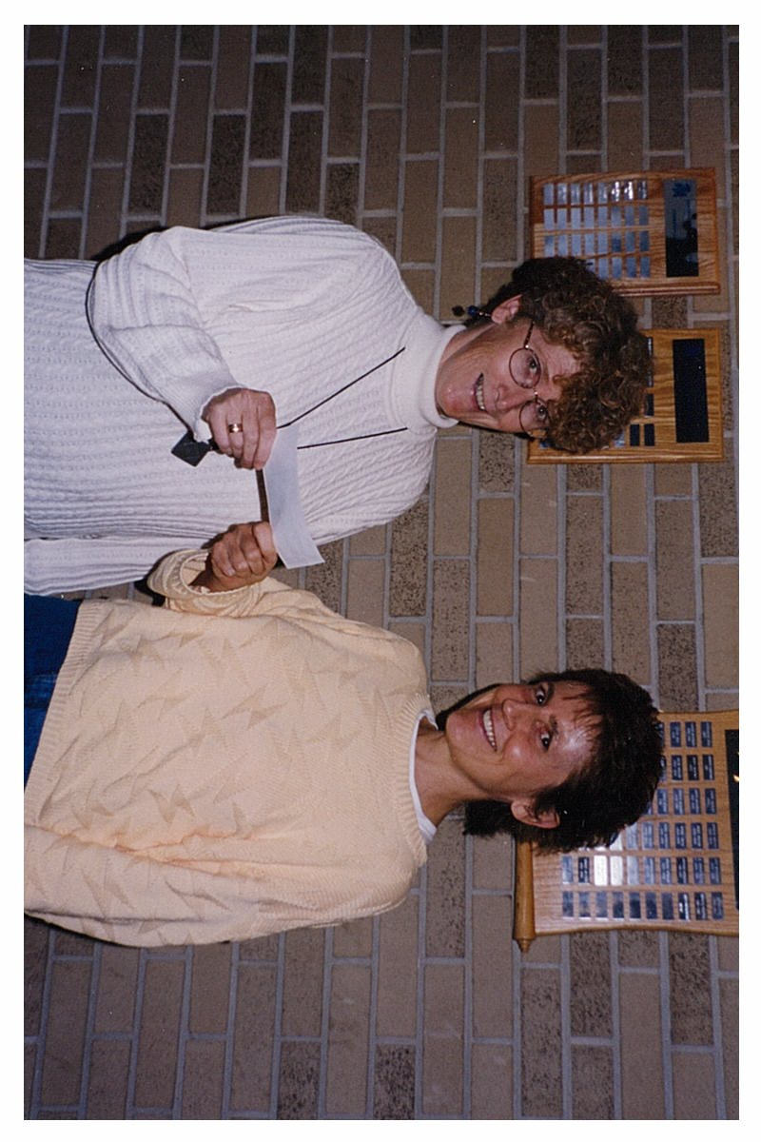
Figure 5: Marion McKay presenting Allemang Award to Veryl Tipliski, 1999

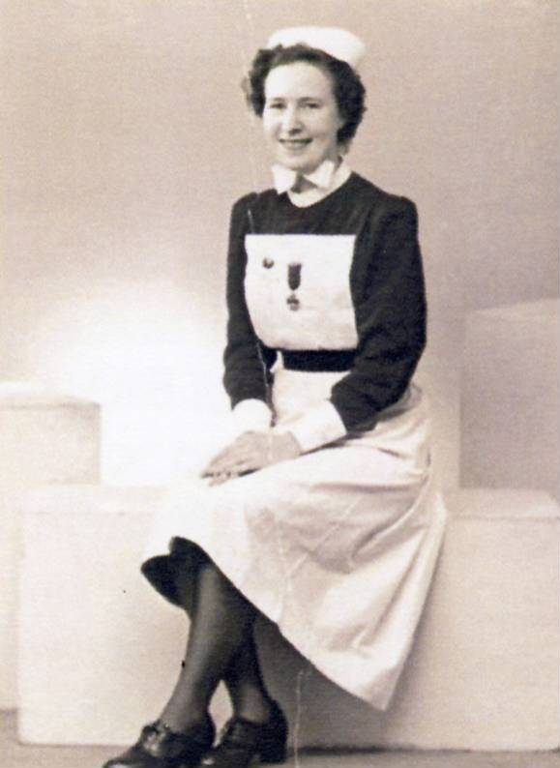
More difficult to put in place was the Vera Roberts award. Out of the blue in 2005, CAHN received word that the association was the beneficiary of an endowment of $200,000 from the estate of Vera Roberts. Roberts, a former CAHN member, had spent her entire nursing career in the Canadian far north, much of this time as a regional nursing officer in Medical Services. The parameters of her legacy were clear and reinforced by the family: the money was to be used to support research only in the northern, especially circumpolar, regions of Canada. President Anne-Marie Arseneault and her executive were already dealing with a treasurer under a cloud of suspicion for decidedly irregular practices, and they were further surprised with the knowledge that the treasurer had also let CAHN’s charitable status lapse, which was a condition of the endowment.

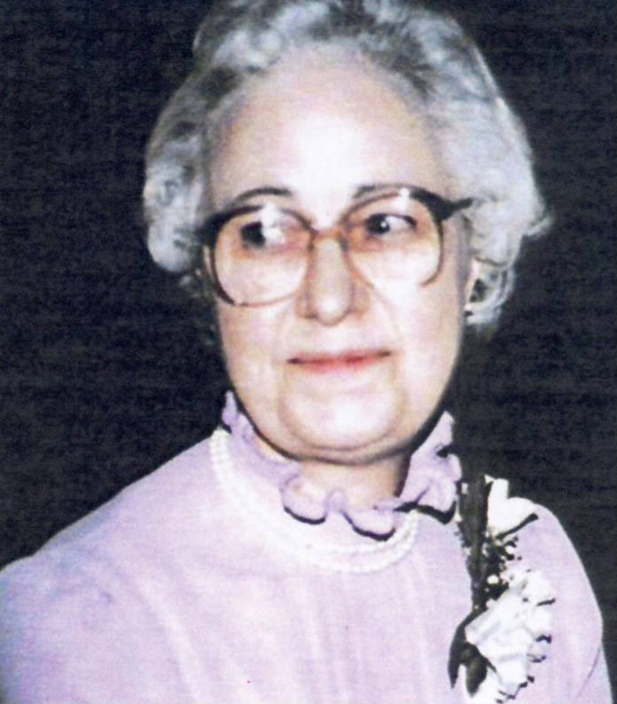
Carol Helmstadter remembered that she and Anne-Marie were “so beside ourselves and Anne-Marie having to try to hold off the executor of the Vera Roberts because we knew we were very deserving of charitable status but we actually didn’t have it when we got that information.” Anne-Marie, Carol Helmstadter and Judith Hibberd scrambled to retrieve the books and the remaining CAHN funds, and, in a race against time, pushed and prodded a slow-moving Revenue Canada into re-instating this requirement in time to receive the bequest. Since 2007, the awards committee has worked very hard to encourage researchers working in what is admittedly a somewhat constrained area to apply. (LIST) To help publicize the award, Joyce McQueen visited the Roberts archives, held at the library of the Northern Ontario School of Medicine in Thunder Bay and wrote a short biography of her that CAHN published in 2009.

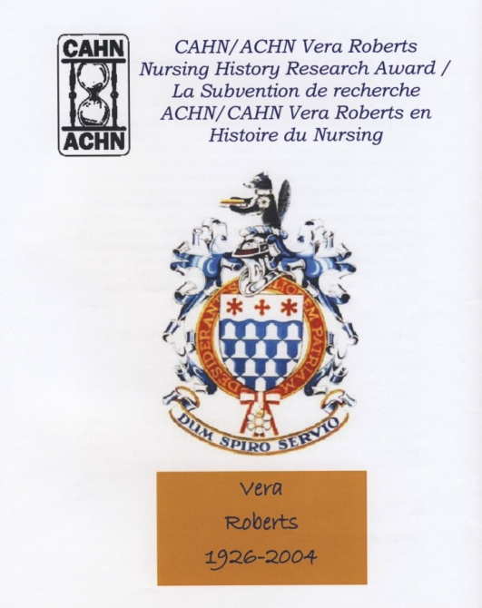
Vera Roberts Award Winners
2007 Carol Helmstadter, Judith Young
2008 Kristin Burnett, Myra Rutherdale
2009 Joyce McQueen
2010 Kristin Burnett
2011 Myra Rutherdale
2012 Lesley McBain

CAHN has also benefitted from funding from the Hannah Foundation or Associated Medical Services as it is now known. From the beginning it has helped support conference keynote speakers, and from 2004 on, has also supplied some funding to help with student travel to annual meetings. Until it was shut down, its competitive grant program benefitted members who were PhD students, postdocs, and even independent scholars. AMS’s executive directors have attended CAHN meetings over the years although it remains to be seen, after the death last spring of Bill Shragge, the most recent executive director, whether or not this tradition will continue. As we all know, current funding opportunities for nursing – and health and medicine in general – seem to be shrinking. Geertje Boschma currently serves as CAHN’s representative on the research committee with Sasha Mullally and others of CSHM to discuss with them major funding bodies the predicament in which researchers in this field find themselves.

CONNECTIONS WITH OTHER ORGANIZATIONS
A fourth and for now final theme we see running through CAHN’s history is its connections to other organizations. Part of Keddy’s inspiration in starting CAHN was her contact with Monica Bayly of the nursing history group associated with the RCN in England. Although she admitted that she felt close to the British group of historians, Keddy resisted any overtures to join more closely with the American Association – similar to Allemang’s feelings mentioned earlier, she feared absorption into a North American organization and wanted to maintain a Canadian identity. Nonetheless, CAHN was proud of its first international nursing history conference, held in conjunction with the AAHN in St. John, NB in 1992. Another collaborative effort with the AAHN was the 2003 meeting in Milwaukee, which was particularly eventful for those members having to skirt severe thunderstorms to get there.

Connections with International Council of Nurses (ICN) have been more tenuous, although the BC History of Nurses Association agreed to host the annual conference in Vancouver when the ICN met there in 1997. Two CAHN members, Meryn Stuart and Geertje Boschma, were also involved in writing the history of the ICN.

For awhile, CAHN believed that conference attendance would benefit from holding the annual meetings in the same place and time as the CNA biennials. The problem was what to do during CNA’s “off” years. After the meeting in Charlottetown, CAHN had a smaller event in Quebec City in 1989, although that does not appear to have been the case for the one held in Kingston in 1991. However, the proposal to hold a workshop retreat in 1993 was decisively rejected by the majority of members and since then, all annual conferences have followed the familiar format. Once CAHN received special interest group status with CNA in 1992, someone from the CAHN executive attended the meetings for what are now called associate and affiliate groups until around 2004. Repeating patterns from the past, we are once again weighing the pros and cons of maintaining our status as an associate group with CNA.
The first of the joint meetings with CSHM began in 1998, but since 2007 the association has met every other year with it under the umbrella of the Federation of the Humanities and Social Sciences’ annual Congress, formerly known as “The Learneds.” This relationship has now been formalized through an MOU drawn up by Geertje Boschma and Pat Prestwich and to which both societies have agreed. Although CAHN’s financial picture has remained relatively stable recently, thanks in large part to astute investments made by Carol Helmstadter when she was treasurer, it has been pointed out that independent CAHN conferences are a source of revenue for the association, something that is not possible with those that are joint. But as Geertje Boschma believes, “opportunities for interdisciplinary connections and networking with related fields contribute in an important way to working towards our goals of bringing nursing history scholarship to the attention of a wider audience.” Some informal discussion has also ensued over the past few years over whether or not full amalgamation with CSHM would be of benefit to the association.

CONTRIBUTIONS OF CAHN
Although CAHN always welcomed both nurses and non-nurses to the organization, it provided a critically important place (organizationally) and space (intellectually) for nurses who wanted to be involved in nursing history - a welcoming environment where they could connect with others in this field and find support for their work. As Anne-Marie Arsenault said, “We fought long and hard to get nursing history recognized and valued.” Although some faculty members like Meryn, Cynthia, Marie-Claude, Geertje, and Sonya have been fortunate in being able to teach fully-fledged history of nursing courses in recent years, others, like Diana Mansell, Barbara Keddy, and Lynn Kirkwood have had to use various strategies by which they managed to insert nursing history into mainstream nursing courses during earlier years.

CAHN members have both created and preserved primary sources for doing nursing history and in addition, they have been active politically to argue for the preservation of those that are endangered – the prime example being CNA historical artifacts and records. CAHN has raised the visibility of nursing history through our various activities – whether intentionally as an organization or through our individual members’ opportunities. Several mentioned the increase over time in the quality and volume of nursing history research presented at meetings. CAHN has supported the development of historical scholarship on Canadian nursing history. Lynn Kirkwood and others emphasize the importance of CAHN’s scholarship and awards program in supporting new scholars; as we have learned, at least 15 graduate students have received funding from the Allemang scholarship and 6 emerging or established historians from the Roberts’ award. CAHN members have also met with and continue to fight for funding of nursing history by the main granting agencies (SSHRC, CIHR, AMS) over the past years – an ongoing saga.
In terms of productivity, Carol Helmstadter believes that proportionately speaking, CAHN members have produced more work than their American counterparts. Beverley Hicks noted the support for PhD studies in nursing history and the increasing number of doctoral-prepared historians as members of CAHN. Apart from the many books and articles that CAHN members have produced, CAHN itself published the first 10 years of keynote addresses, and many others produced books on Canadian nursing primary sources.

Marg Gorrie contends that a national association helps us better understand one another in a country that’s really unwieldly because it’s too big.” Although the need to develop Canadian nursing history has had priority due to the paucity of studies at the beginning, CAHN has also been highly supportive of the move towards both international and interdisciplinary histories – Canadian researchers attend, present at and publish from international conferences , some of which CAHN itself has organized. McKay agrees, stating that “If you think of Carol, and Sonya, and Geertje, who are being asked to speak all over the world and are published. I think our contribution has been disproportionate to our numbers.”

DIRECTIONS FOR THE FUTURE

Among those interviewed, sustainability and visibility were the two key factors emphasised and they are interrelated. Most were somewhat pessimistic about the fate of nursing history in nursing school programs. Diana admits that CAHN has raised awareness of nursing history, but she laments that “overall we haven’t done what we wanted to do, which was to get a nursing history course in the curriculum … across the board.” One was unsure that nurses in general were any more interested in history than 25 years ago, and another stated that nurses with nursing history theses would never get hired in her province.

As past presidents remind us, membership remains a problem – retired members make up the bulk of membership. While support for bilingual nursing history and historians is increasing, we still have a long way to go. CAHN should encourage all signs of new life, for example, the new history of nursing group in Nova Scotia. To find strength in numbers, CAHN should nurture its international connections and members should reach out to undertake more comparative research. Another feared, however, that too much emphasis on being a scholarly association might make it less welcoming for practising nurses. For one, this was a reason to merge with CSHM under the larger umbrella of health care history; another argued against losing what she felt was CAHN’s current strong identity that members had worked so hard for. Nonetheless, all thought CAHN’s efforts so far were worth sustaining.

At this point, the challenges of an organizational history are evident – balancing CAHN’s achievements with the more contentious relationships within the organization at time are acknowledged as both growth and pain. The value of such a retrospective look at the 25-year point is to set the context for a productive discussion about the future and the issues that concern us – membership, scholarship, relations with CNA and CSHM, nursing history in the curriculum, and archives.

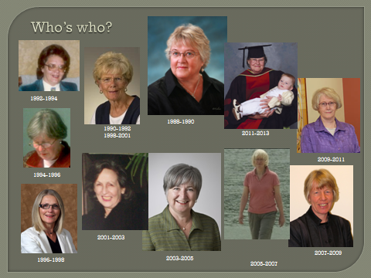

ENDNOTES

Barbara Keddy, interview with Jayne Elliott, 7 May 2012, p. 2.
Allemang interview, p. 35.
Margaret Allemang, interview with Natalie Riegler, 9 March 1993, p. 6.
Keddy interview, p. 3.
For a brief history of the AAHN, see Laurie K. Glass, “AAHN – The Birth of an Organization,” Journal of Professional Nursing 6 (May-June 1990): 136, 185.
See Glass, “AAHN.” An early history of nursing society was founded by students of the History-of-Nursing Class at Teacher’s College in 1927. Inspired by Isabel Stewart, the student-led group conferred with Adelaide Nutting herself on the objectives and proposed activities. See Hally Flack, “A History-of-Nursing Society: Organized by Nursing Students of Teachers College,” American Journal of Nursing 7, no.7 (1927): 553-5.
Letter from Margaret Allemang to Barbara Keddy, 14 October 1986, p. 3.
Letter from Natalie Riegler to Margaret Alleman, 18 October 1986.
Letter from Isabel MacRae to Margaret Allemang, 11 November 1986. See also Letter from Meryn Stuart to Barbara Keddy, 14 November 1986.
Letter from Irene Goldstone to Barbara Keddy, 14 November 1986.
Letter from Shirley Stinson to Barbara Keddy, 28 October 1986.
Letter from Barbara Keddy to Margaret Allemang, 1 December 1986.
Keddy interview, p. 4.
Keddy interview, p. 4.
Sharon Richardson from the University of Alberta argued that nurses from the four western provinces would find going to PEI too expensive and suggested that CAHN might also like to schedule a history session at the next Canadian National Nursing Research Conference, which was being held in Calgary in October 1988. Although Keddy wrote to Joy Calkin, the conference organizer, there is no record of Calkin’s response to this idea. See Letter from Sharon Richardson to Barbara Keddy, 25 July 1987; Letter from Barbara Keddy to Joy Calkin, 17 August 1987.
Keddy interview, p. 6.
Allemang interview, p. 10
Allemang interview, p. 9.
Keddy interview, 6-7. Keddy went over to England the following year to attend the nursing history conference and agreed with Bayly’s assessment.
Barbara Keddy, “Provisional president’s year-end report CAHN/ACHN, 16 June 1988, p. 1-3.
Letter from Barbara Keddy to Jayne Elliott, 22 November 2011; Keddy interview, p. 3-4.
Allemang interview with Riegler, p. 14-15.
See Kathryn McPherson, “Nurses, Archives and the History of Canadian Health Care,” Archivaria 41 (Spring 1986): 108-120; Barbara L. Craig, “Memories and the Memorial: Developing and Managing Nursing Archives for Canada, Canadian Bulletin of Medical History / Bulletin canadien d’histoire de la médecine (CBMH/BCHM)11, no. 1 (1994): 237-248.
Nonetheless, members Arlee McGee and Penny Ericson were involved in 1991 in setting up the Women’s Studies in Nursing Research Group at the University of New Brunswick, which pulled in an impressive list of consultants that included Anne-Marie Arseneault. A year later they were developing a course entitled “Nurse in Fact, Fiction, and Film.” CAHN / ACHN Newsletter, Vol. 4 (Spring 1992), p. 2
Laura Coles, ed., Survey of Nursing History Materials In British Columbia (Vancouver, 1990); Kathleen McMillan and Judith Young, A Guide to Nursing Historical Materials in Ontario (Toronto” Ontario Society for the History of Nursing, 1994); Lorraine Mychajlunow and Sharon Richardson, A Directory of Nursing Archival Resources in Alberta (Edmonton, 1996); Arlee McGee, A Guide to Health Care History Material in New Brunswick, 1998; Diana Mansell, Guide to Canadian Nursing Archival Resources (Canadian Association for the History of Nursing/Association canadienne pour l’histoire du nursing, 2002). Gertrude Jacobs of Montreal was involved in putting together Collection des livres du service des archives, a list of books and papers in the QIIQ’s archives. See CAHN Newsletter, 4, no. 2 (Spring 1992), p. 2.
Keddy’s tapes of early nurses in Nova Scotia are in the provincial archives there, Allemang’s oral histories of Canadian military nurses are now in the University of Toronto Archives. The BC History of Nursing Group conducted interviews with retirement-age nurses in 1987 that were deposited in the RNABC library, Kathryn McPherson’s histories of graduates of the Winnipeg General Hospital school of nursing are deposited in the Public Archives of Manitoba, Cynthia Toman’s of Second World War military nurses are in the Canadian War Museum.
Carol Ferguson, “Re-Connecting with the History of Labour in New Brunswick: Historical Perspectives on Contemporary Issues / Nouveau regard sur l’histoire du travail au Nouveau-Brunswick : Les enjeux contemporains vus dans une perspective historique,” Acadiensis 37 (Winter/Spring 2008), http://journals.hil.unb.ca/index.php/acadiensis/article/view/5749/11049, accessed 4 June 2012.
Sherwin B. Nuland, “Doctors and Historians,”Journal of the History of Medicine and Allied Sciences 43 (1988): 137-140; Lloyd G. Stevenson, “Book Review “A Second Opinion,” Bulletin of the History of Medicine 54 (1980): 134-140; Philip M. Teigen, “An Apology for Commemorative History: An Essay Review,” Journal of the History of Medicine and Allied Sciences 51 (1996): 79-85; and Leonard Wilson, “Medical History Without Medicine,” Journal of the History of Medicine and Allied Sciences 35 (1980): 5-7.
Ina Bramadat, President’s Message, CAHN/ACHN Newsletter 5, no. 1 (Fall 1992), p. 1.
Executive Minutes, 1993, Ina Bramadat, CAHN/ACHN update (August 1993).
Keddy interview, p. 7.
Lynn Kirkwood interview.
Diana Mansell interview.
Interview with Geertje Boschma by Jayne Elliott, 11 May 2012.
Keddy interview, p. 6.
Geertje Boschma, “President’s Message” CAHN/ACHN Newsletter 21 (Spring 2008), p. 1.
Interview with Marg Gorrie by Cynthia Toman, 12 April 2012.
Interview with Marion McKay by Jayne Elliott, 7 May 2012.
Interview with Diana Mansell by Jayne Elliott, 16 May 2012.

